Chronicles of Humanity Order Form

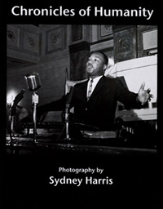
Sydney "Syd" Harris was a committed photographer with a beautiful eye for humanity. His direct, social realist style is unassuming yet revelatory. Harris, a veteran of the Spanish Civil War and Lincoln Brigade, worked as a photographer and journalist for many of the major unions in Chicago from the mid 1950s until his death in 1989. His works show us the “city of big shoulders” Black, latino and white workers from the steel mills, auto plants and kitchens of fancy hotels are portrayed here--working class men and women now fading from today's world of computers and factory shut-downs.

Caught too are major political and cultural figures of the 1960s. Here is Dr. King leading street protests, Carl Sandburg reading a poem, Paul Robeson challenging power and President Kennedy staring intently at a young women across his banquet table. Included are photos never before shown of the emergency care room as protestors stagger in bloody and beaten by the Chicago police during the 1968 Democratic convention. This photo book is an insightful historical record and treasure of urban industrial America and those days when picket lines and demonstrations change the country.

PLEASE PRINT CLEARLY

Name
Address 1
Address 2
City
State/Province
Postal Code
Country
# | Title | Cost | Total
 | Chronicles of Humanity | 15.00
 |  | Subtotal:
Makes checks payable to:  Jerry Harris |  | Shipping: | FREE
 |  | Total Enclosed:
Send to:
Jerry Harris
1250 N. Wood Street
2nd Floor
Chicago, IL 60622
Name
Address 1
Address 2
City
State/Province
Postal Code
Country
-------------------------------------------------------------------------------------------------
# | Title | Cost | Total
 | Contested Terrains of Globalization | 15.00
 | Complimentary Copy  (included with all 3 day registration costs) | 0.00 | 0.00
 |  | Amount Due:
 |  | Cash:
 |  | Check #:
Makes checks payable to Global Studies Association.

